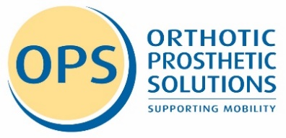
Parental/Guardian Consent Form

I hereby give my permission for my child’s photo / image / video to be published on the OPS Website / Facebook Page / Instagram Feed or used in OPS printed material (the public will be able to like and/or share the page. Only first name of your child will be used.) I waive any rights, claims, or interest I may have to control the use of my child’s image in whatever media is used. I understand that there will be no financial or other remuneration, either for initial or subsequent print, transmission or downloads.

Child’s Name:

Parents Signature:

Date:

